Episcopal Churchwomen of the Diocese of Virginia
ECW Spring Meeting
Saturday, May 8, 2021 9:00 a.m. – 12:00 noon

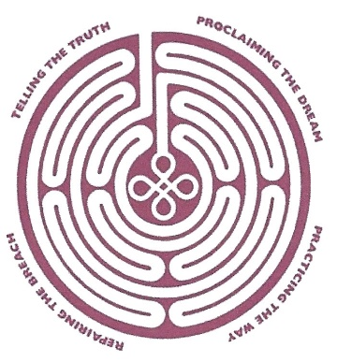
The Episcopal Church’s long-term commitment to racial healing, reconciliation and justice is “Becoming Beloved Community.” Please join us in this journey. We are organizing our efforts for meetings around the quadrants of the labyrinth image used by the Church. We are also including the goals of the Diocese of Virginia. In this meeting, we will focus on “Telling the Truth,” “Healing Across Difference, and “Repairing the Breach.”
9:00 – 9:50 - Business Meeting
10:00 – 10:30 – “Telling the Truth” and “Healing Across Difference”
with The Rev. Canon Jesus Reyes
10:30 – 11:00 – “Repairing the Breach”
with Michelle Trampe, who will provide an
update on human trafficking
11:15 – 12:00 – Worship led by the Very Rev. Kim Coleman

1 We borrow the labyrinth image gratefully from Archbishop Desmond Tutu and the Rev. Mpho Tutu’s work in The Book of Forgiving, although we have surrounded the labyrinth with The Episcopal Church’s long-term commitments.
The virtual gathering is powered by Zoom. To register click the link below and follow the prompts. After registering, you will receive a confirmation email containing information about joining the ECW Spring Meeting.

https://us02web.zoom.us/meeting/register/tZUvf-urqDgpG9GezuFcU9iJlphLUoIUAhwy
We are asking for contributions to compensate our facilitators. The suggested amount is $25.00; however, any amount is gratefully accepted. Checks made out to ECW/Virginia Diocese should be mailed to the ECW treasurer: Kaaron Austin,
7319 Willson Road, Henrico, VA 23231.

