Church Periodical Club Coming
EVENTS
March 1 – 30 Quilt Raffle
Two beautiful quilts: one of Hawaiian heritage materials (twin) and a second machine quilt queen in pink rose and tan. It is available for you to get your tickets thru your computer http://go.rallyup.com/cpc2022
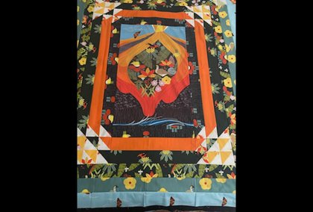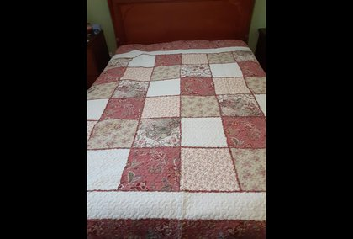
Our quilt auction provides funds for operations of CPC. Lets see how many dioceses we can get to participate………Put your Diocese under listing
Each day is a privilege when we have access to written word whether it be electronic or printed.

Church Periodical Club (CPC) is dedicated through grants to provide written materials thru the Episcopal church both within and throughout the world. CPC only receives funds through gifts (donations).

So how does a quilt raffle support CPC??? It provides administrative funds for our website and expenses to increase the ministry.

This year's quilts are two very different ones. Hawaiian vintage material quilt is a beautiful work of art using historically designed material for a twin bed. Our second quilt was a machine stitch queen size quilt donated by a 80+ woman who could no longer quilt with a note saying " when I read my Bible I know how lucky I am.
Questions?????Contact Louise Lana Aloy (Diocese of Hawaii) louisealoy63@gmail.com or Maryfran Crist (Diocese of Chicago) maryfrancrist64@gmail.com 815-257-7012.

