The Episcopal Church Women of the Diocese of Virginia Fall Meeting & UTO Ingathering
Theme: "Do not be afraid; I will restore you; I will renew you."
Keynote speaker: The Rt. Rev’d E. Mark Stevenson
Speaker: The Rev. Dr. J. Lee Hill Jr.
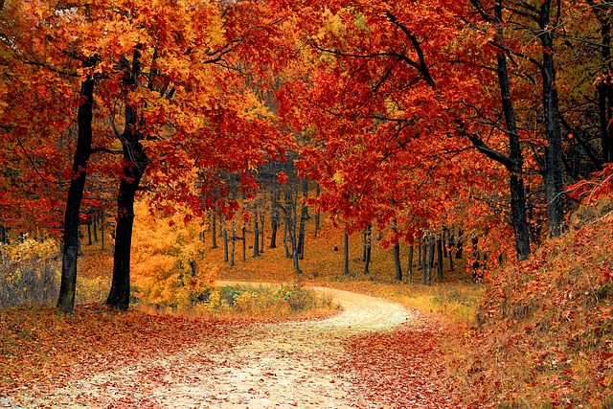
When: Saturday, November 11, 2023
Where: St Mary’s, 203 Dennison Street, Colonial Beach
(Visit their Thrift Shop following our Holy Eucharist!)
Time: 9:00 AM Registration/Continental Breakfast, 10:00 Meeting, Noon Lunch, 1:00 PM Holy Eucharist
Questions: Email ECW President, Ericka Masias erickamasias@outlook.com
-----------------------------------------------------------------------------------------------------------------------------------------------Please return bottom of this registration form with $25 Registration fee checks payable to: ECW Diocese of VA Mail check and registration to: ECW Treasurer - Kaaron Austin - ausink11@aol.com, 7319 Willson Road, Henrico, VA 23231 Deadline for Registration November 1st!
Name: ________________________________________________________________________________________
Home Church (if have one): __________________________________________________Region: ______________
Phone: _______________________________________________________________________________________
Street Address: _______________________________________________________________________________
City: ____________________________________________________ State: _______________ Zip: ____________
Email: _______________________________________________________________________________________
Buffet Lunch will be provided. Please specify any dietary needs: __________________________________________
Hotel Info: The Riverview Inn welcomes ECW with a 10% discount rate on Nov 10th and 11th. Rooms with Full, Queen or 2 Queen beds, bottled water, unlimited coffee in the lobby and so much more. Located 1/2 block from the water and a couple of blocks from the St. Mary's Episcopal Church. To make a reservation, please call (804) 224-4200 and use Code ECW2023. Colonial Beach – November 10 – Friday Night Art Walk 6 PM – 9 PM

